**Sprint 3 Report**

**Product Name: Beads Net**

**Team Name: Weaver**

**Date: 11/18/2018**

**• Actions to stop doing:** We should stop doing things on our own without notifying others about the progress. We should stop writing minimum comments.

**• Actions to start doing:** We should start to write clean code in order to efficiently collaborate other’s works. We should start to look at other similar web pages.

**• Actions to keep doing:** We should keep accepting suggestions. We should keep exploring different APIs to refine our movie data source.

**• Work completed/not completed:**

**(Completed)User story 1:** As a developer, I want to put the result from search into data structure, because I can easily use these information later on.

Task 1 - Design a data structure to store results that initially derived from search. (8hr) (completed)

Task 2 - Build the data structure (5hr) (completed)

Task 3 - Put API results into data structure. (3hr) (completed)

Task 4 - Rebuild search result page using data from data structure. (2hr) (completed)

Total time for user story 1: 18 hours

**User story 2:** As a user, I want to be able to have a profile because I want a place to save my information like my preference.

Task 1 - Design a UI for user profile page (3hr) (completed)

Task 2 - Make the layout for profile page according to the design (3hr) (completed)

Task 3 - Link the profile page to database (5hr)

Task 4- Enable the users to save their profile information (2hr)

Task 5- Enable the users to edit their profile information (2hr) (deleted)

Total time for user story 2: 15 hours

**(Completed)User story 3:** As a developer, I want to redesign the spider-net web way of showing result, because this feature is way harder than we expected.

Task 1 - Research on the similar website or other apps that contain similar functions (8 hr) (completed)

Task 2 - Discuss and plan the algorithm or way to accomplish this feature (8 hr)(completed)

Task 3 - Make a draft spider-net looking distribution. (16 hr)(completed)

Total time for user story 3: 32 hours

**(Completed)User Story 4:** As a user, I want to be able search for movie instead of youtube video because I want to watch movies.

Task 1 - Read the Tmdb api documentation (5hr)(completed)

Task 2 - Implement Tmdb api so there are results presented (5hr)(completed)

Task 3 - Modified the javascript so there are posters and description (8hr)(completed)

Total time for user story 4: 18 hours

**• Work completion rate:** The total number of user stories completed is 76 hours. The total number of estimated ideal work hours competed is 83 hours.

**Total number of user stories completed: 3**

**Total number of estimated ideal work hours completed: 83 hours**

**Total number of days during the prior sprint: 14 days**

**The average user stories/day**: **0.214**

**The average ideal work hours/day figures: 5.93hr**

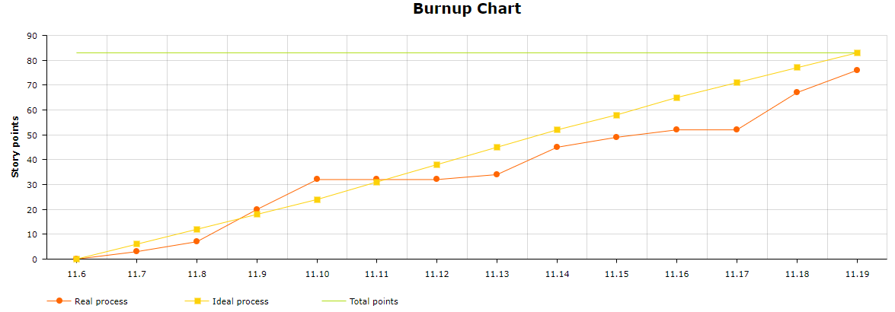

|  |  |  |  |
| --- | --- | --- | --- |
| **User story** | **To do** | **In progress** | **Done** |
| **User story 1:** As a developer, I want to put the result from search into data structure, because I can easily use these information later on. |  |  | **User story 1:** As a developer, I want to put the result from search into data structure, because I can easily use these information later on. |
| **User story 2:** As a user, I want to be able to have a profile because I want a place to save my information like my preference. | **User story 2:** As a user, I want to be able to have a profile because I want a place to save my information like my preference. |  |  |
| **User story 3:** As a developer, I want to redesign the spider-net web way of showing result, because this feature is way harder than we expected. |  |  | **User story 3:** As a developer, I want to redesign the spider-net web way of showing result, because this feature is way harder than we expected. |
| **User Story 4:** As a user, I want to be able search for movie instead of youtube video because I want to watch movies. |  |  | **User Story 4:** As a user, I want to be able search for movie instead of youtube video because I want to watch movies. |